(TRACEME)

(BSE 16-29)

Team Members

|  |  |  |
| --- | --- | --- |
| NAME | STUDENT NUMBER | REG. NUMBER |
| AKENA KENEDY | 212012186 | 12/U/3289/EVE |
| LUBANGAKENE SIMONPETER | 212017661 | 12/U/7727/EVE |
| NSIIMIRE CHRISTINE | 212013086 | 12/U/12762/EVE |
| OKOT DANIEL | 212013253 | 12/U/13362/EVE |

**Software Requirements Specification**

**Document**

**Version: (1.0)** **Date: (12/11/2015)**

Table of Contents

1. Introduction 4

1.1 Purpose 4

1.2 Scope 4

1.3 Definitions, Acronyms, and Abbreviations. 4

1.4 References 5

1.5 Overview 6

2. The Overall Description 6

2.1 Product Perspective 6

2.1.1 System Interfaces 7

2.1.2 Interfaces 8

2.1.3 Hardware Interfaces 8

2.1.4 Software Interfaces 8

2.1.5 Communications Interfaces 9

2.1.6 Memory Constraints 9

2.1.7 Operations 9

2.1.8 Site Adaptation Requirements 10

2.2 Product Functions 10

2.3 User Characteristics 10

2.4 Constraints 10

2.5 Assumptions and Dependencies 10

2.6 Apportioning of Requirements. 11

3. Specific Requirements 11

3.1 External Interfaces 13

3.2 Functions 16

3.3 Performance Requirements 16

3.4 Logical Database Requirements 17

3.5 Design Constraints 17

3.5.1 Standards Compliance 18

3.6 Software System Attributes 18

3.6.1 Reliability 18

3.6.2 Availability 19

3.6.3 Security 19

3.6.4 Maintainability 19

3.6.5 Portability 19

4. Change Management Process 19

5 Document Approvals 20

6 Supporting Information 20

# 

# 1. Introduction

This Software Requirements Specification (SRS) document describes the requirements of traceme system (embedded and mobile application). The SRS begins with an introductory section describing its overall purpose, scope, and defining terms and acronyms that will be utilized therein. The following section will describe the software product in detail, including functions, constraints, and user characteristics. Then, a detailed list of requirements will be provided, after which those requirements will be modeled using use case diagrams, class diagrams and activity diagrams and entity relationship diagrams.

## 1.1 Purpose

The purpose of this Software Requirements Specification (SRS) document is to provide a complete description of both the purpose and functionality of the software system that is to be developed. This document includes the details of the specific system requirements, the overall product description, and design considerations, etc as explained below.

The main intended audience for this SRS is the passengers and the police men for whom the system is to be implemented for. However the SRS document may also be useful to others, such as the developers, automotive engineers who might be trying to understand the interactions of the system with other vehicle components.

## 

## 1.2 Scope

The software described in this SRS document is called traceme system. It is designed as an android mobile and embedded system to be used in passenger vehicles. The major goals of the system are to provide convenience and safety measures to passengers and also provide an ease in investigation by the police department in case of any criminal act in regards to the passenger.

The traceme mobile application will attempt to constantly provide information and the location of any vehicle in case a passenger has lost his or her property, any criminal activity subjected to the passenger. The passenger logs on to the system immediately he or she enters into a vehicle and takes the license number of the vehicle. Through the help of the GPS the vehicles shall be tracked and hence ensuring safety of the passengers and easing the investigation by the police department. The system will not recover the lost property by itself but it will provide necessary information in order to recover.

## 1.3 Definitions, Acronyms, and Abbreviations.

**SRS**: Software Requirements Specification: A complete and in-depth document describing the behavior and purpose of a system to be developed.

**GPS**: Global Positioning System is a worldwide radio-navigation system formed from a constellation of 24 satellites and their ground stations.

**Longitude**: The angular distance east or west of the earth's equator, measured in degrees along a meridian, as on a map or globe.

**Latitude**: The angular distance north or south of the earth's equator, measured in degrees along a meridian, as on a map or globe.

**Web Client**: A computer interface that is utilizing a Web server (usually through a web browser). Our web client will connect to our tracking information web server page. This page will contain information on every GPS coordinate for the specified login. This client will also have mapping where a user can visually see their vehicles move on the map.

**Database**: A collection of information stored in a computer in a systematic way. This will refer to a place on our server.

**Web Server**: A computer, including software package,that provides a specific kind of service to client software running on other computers. Our Web Server will receive data requests from all our different client types.

**AJAX**: AJAX or Asynchronous JavaScript and XML is a term describing a web development technique for creating interactive web applications

**Google Maps**: A free, online map service provided by Google at http://maps.google.com.

**API** (Application Programming Interface): Is a set of routines and/or protocols provided by libraries and/or operating system services in order to support the building of the applications.

**FR** Functional requirement

**DESC** Description

## 1.4 References

[1] “GSM/GPRS module”, https://www.sparkfun.com/products/9607

* + 1. Reference mapping systems
       1. <http://www.mapquest.com/directions/main.adp?bCTsettings=1>
       2. <http://maps.google.com/>
    2. Automobile real-time tracking systems
       1. <http://www.lojack.com/>
       2. <http://www.rmtracking.com/>
       3. <http://www.hunterpro.com/>
       4. <http://www.interfleet.com/>
       5. <http://www.interfleet.com/news/EMS%20Insider%20--%20InterFleet%20article.pdf>
    3. Portable GPS vehicle navigation systems and traffic watchers
       1. <http://www.tomtom.com>
       2. <http://www.garmin.com>
       3. <http://www.tomtom.com/plus/services/traffic.php>
       4. <http://www.garmin.com/traffic>
       5. <http://www.magellangps.com/>
       6. <http://www.magellangps.com/products/traffic_service.asp>
    4. Cell phone tracking and locator services
       1. <http://www.accutracking.com/>
       2. <http://marketplace.publicradio.org/shows/2007/05/31/AM200705315.html>
       3. <http://www.technewsworld.com/story/49933.html>

## 1.5 Overview

The remainder of this document includes six chapters. Chapter one is the introduction which majorly contains the brief introduction of the requirement specification document.

The second chapter provides an overall description of the system, the product perspective showing system functionality and its interaction with other systems; it also introduces different types of stakeholders and their interaction with the system. Furthermore, the chapter also mentions the system constraints and assumptions about the product. This chapter is of great help to the potential users of the system/customers who are interested to know about the system.

The third chapter provides the requirements specification in detailed terms and a description of the external interfaces of the system, the design constraints. The chapter is of great help to the design team and the technical experts who will be in charge of implementation and seeing that the features as stated are brought to life.

Chapter four basically is about the change management process. The rest of the chapters are about document approvals and support documentation as chapter five and six respectively.

Chapter six is of great importance to all stakeholders of the system.

# 2. The Overall Description

This section will give an overview of the whole system. The system will be explained in its context to show how the system interacts with other systems and introduce the basic functionality of it. It will also present the constraints and assumptions for the system.

Besides, the section will talk about the different interfaces including hardware, software, and communication. e.t.c.

## 

## 2.1 Product Perspective

The system shall basically consist of client part, server part and GPS part.

The users shall use their hand held mobile devices to see and search the users’ and vehicles’ information in to the system repository. The most important component of our system is GPS that shall continuously receive geographic coordinates from the satellites of the vehicles’ locations. The vehicle’s location information is read in from the GPS module by the micro-controller. Besides, the vehicle’s location information and the vehicle’s license number are then transmitted to the web server through GSM/GPRS network.

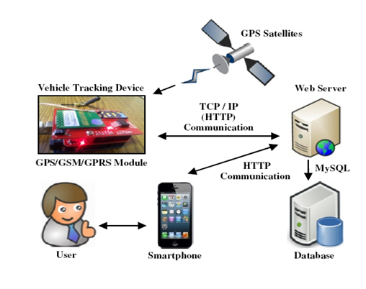

Fig 1: A block diagram showing the major components of the TRACEME system, and the interconnections.

### 2.1.1 System Interfaces

**Android mobile interface**

The mobile based interface is used to display location based information about a particular vehicle through the use of Google Cloud Messaging (GCM) which pushes on notifications to the user from the web.

The notification shall then be used to show the location of the vehicle using the google API.

**A web portal interface**

The web based interface majorly retrieves the location of the vehicle in terms of longitude and latitude values and throws it to the Google maps where the location shall then be reflected on the handheld android devices through the use of push notifications.

**Embedded interface**

The interface basically contains different components including the GPS device, Arduino micro-controller and the GPRS/GSM.

The GSM/GPRS module [1] is responsible of establishing connections between an in-vehicle device and a remote server for transmitting the vehicle’s location information, using TCP/IP connection through the GSM/GPRS network.

The GPS shall be installed on the vehicle to provide location of the vehicle using coordinates and then the mobile device shall sink with the GPS with the help of the unique identification number entered in by the mobile user.

### 2.1.2 Interfaces

The system will provide a log in page for the mobile user to log in to the system via his mobile phone. The log in details of the passenger will be automatically received at the web side and this information will be captured alongside the location readings of the vehicles by use of GPS. The information will be stored and retrieved at any time of need.

### 2.1.3 Hardware Interfaces

Since neither the mobile application nor the web portal have any designated hardware, it does not have any direct hardware interfaces. The physical GPS is managed by the GPS application in the mobile phone and the hardware connection to the database server is managed by the underlying operating system on the mobile phone and the web server.

### 2.1.4 Software Interfaces

In this subsection we shall be specifying the use of other required software products and interfaces with other application system and how they will be incorporated into the proposed system.

#### 2.1.4.1. Google Maps API

**Google Maps** is a desktop web mapping service developed by [Google](https://en.wikipedia.org/wiki/Google). It offers [satellite imagery](https://en.wikipedia.org/wiki/Satellite_imagery), street maps, 360° panoramic views of streets ([Street View](https://en.wikipedia.org/wiki/Google_Street_View)), real-time traffic conditions ([Google Traffic](https://en.wikipedia.org/wiki/Google_Traffic)), and route planning for traveling by foot, car, bicycle (in beta), or [public transportation](https://en.wikipedia.org/wiki/Public_transportation).

A Google maps API for iOS is used to display a vehicle location on a Smartphone application in real-time using an HTTP request. The Google maps API automatically handles access to the Google Maps servers, displays map, and responds to user gestures such as clicks and drags.

### 2.1.5 Communications Interfaces

The communication between the different parts of the system is important since they depend on each other. However, in what way the communication is achieved is not important for the system and is therefore handled by the underlying operating systems for both the mobile application and the web portal.

### 2.1.6 Memory Constraints

Since we shall be handling huge amount of data/information, the following are the minimum requirements needed for our Linux server machines.

Intel Pentium Dual core 2.2GHz, minimum RAM of 2GB and 320 GB of storage.

Besides, the system administrators shall use any computer machine with reasonable memory, hard disk and processor speed. For the case of the passengers, they are required to run the lowest android version and a minimum of about 256MBs of memory.

### 2.1.7 Operations

The Passenger who will be using the android application on the phone will launch the application once in the vehicle and then select the option to scan the QR code to successfully log his/her information to the Server. This information contains the user ID, longitude and latitude of position and the vehicle ID.

The web portal will perform processing and interpretation of the location data of the vehicles and user locations relative to that of the vehicles to be able to produce information relevant for the various parties such as the police in case of investigations taking place.

Update of the of the vehicle position to the web server holding the database will depend on the network signal of the Tracking device with the GPS module attached to it on the Vehicle.

### 2.1.8 Site Adaptation Requirements

* The position to place/attach the tracking device should be firm and secure
* The QR code should be sealed in order to prevent damage and placed in a position where the passengers can easily see.

## 2.2 Product Functions

TRACEME system combines the installation of an electronic device (GPS) in a vehicle, or fleet of vehicles, with purpose-designed computer software at least at one operational base to enable the passenger, the police or a third party to track the vehicle's location. Vehicle information can be viewed on google maps via the Internet on the web portal. In case of our software the device that we are going to use is an android phone and the vehicles will be watched by an administrator using a web application.

## 2.3 User Characteristics

There are three types of users that shall interact with the system: users of the mobile application, police and the system administrator. Each of these three types of users has different use of the system so each of them has their own requirements. The mobile application users can only use the application to log in a unique vehicle identification number and also be able to view the location of the particular vehicle.

The police will not use the mobile application but the web portal instead.

The administrators also only interact with the web portal. They are managing the overall system so there is no incorrect information within it. The administrator can manage the information about passengers by retrieving location information about a particular vehicle.

The intended users of the system especially the passengers should be literate, they should own an android mobile device and finally they should also have prior knowledge on how to use the device.

The administrator should be computer literate to enable him/her navigate through the vehicle information retrieval process.

## 

## 2.4 Constraints

The Internet connection is also a constraint for the application. Since the application fetches data from the database over the Internet, it is crucial that there is an Internet connection for the application to function.

Both the web portal and the mobile application will be constrained by the capacity of the database. Since the database is shared between both application it may be forced to queue incoming requests and therefore increase the time it takes to fetch data.

## 2.5 Assumptions and Dependencies

This section covers the factors that affect the requirements stated in the srs.

Passengers shall possess smart phones. And, their devices shall have access to good inter net.

* One assumption about the product is that it will always be used on mobile phones that have the required properties as described in section 2.1.6. If the phone does not have required described properties needed for the application, the application may not work as intended or even at all.
* The server on which captured information is to be stored shall run over the Internet. Therefore, the user shall be required to have knowledge on how to use the Internet.
* The users understand English since all the instructions are in English.
* The server on which captured information is to be stored shall be available most of the time.

## 2.6 Apportioning of Requirements.

The tracking device shall provide a network for a vehicle on which it is attached such that every passenger who enters the vehicle and launches the application, it will automatically create a log and send it to the database server. And when the passenger leaves the vehicle, the application will automatically send a log to the database indicating the departure of the passenger which contains the location where the passenger leaves the vehicle.

The web portal shall be modified in such a way that it shall be accessed by the registered users.

# 3. Specific Requirements

This section contains all the software requirements at a level of detail sufficient to enable designers to design a system to satisfy those requirements, and testers to test that the system satisfies those requirements.

**3.1 User class 1: Passenger**

3.1.1 Functional requirement 1.1

ID: FR1

TITLE: Download mobile application

DESC: A passenger shall be required to download the mobile application from the application store.

3.1.2 Functional requirement 1.2

ID: FR2

TITLE: Passenger registration - Mobile application

DESC: Given that a passenger has downloaded the mobile application, the passenger shall be required to register through the mobile application. The passenger must provide Name, password, National ID number and phone number.

3.1.3 Functional requirement 1.3

ID: FR3

TITLE: Passenger log-in - Mobile application

DESC: Given that a passenger has registered, then he/she should be able to log in to the mobile application. The log-in information will be stored on the phone and in the future the passenger should be logged in automatically.

3.1.4 Functional requirement 1.4

ID: FR4

TITLE: Scan the Quick Response code (QR code).

DESC: The passenger shall be prompted to enter the unique identification number by use of the QR code that shall be placed on a vehicle.

**3.2 User class 2: Police**

3.2.1 Function requirement 2.1

ID: FR5

TITLE: Police log-in

DESC: The police shall log in to the web portal since they shall be able to trace the location of the vehicle via google maps.

3.2.2 Function requirement 2.2

ID: FR6

TITLE: View vehicle location

DESC: The police shall be able to view the location of the vehicle by use of google maps.

**3.3 User class 3: Administrator**

3.3.1 Function requirement 3.1

ID: FR7

TITLE: Administrator log in In order to administer the system.

DESC: An administrator shall log in to the web-portal using the administrator account.

3.3.2 Function requirement 3.2

ID: FR8

TITLE: Retrieve necessary information during the vehicle tracking process.

DESC: The administrator shall retrieve necessary information required during the tracking and information about a particular passenger.

3.3.3 Function requirement 3.3

ID: FR9

TITLE: Register vehicles

DESC: The administrator shall register the vehicles.

## 

## 3.1 External Interfaces

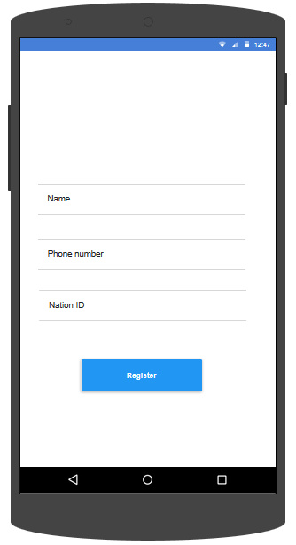

On installation of the mobile application the user will be required to do registration to capture his/her data for future reference within the system. This data includes name, phone number, and National ID number. When entered, it’s submitted and stored in the database. Then user automatically logs in and is provided with the home screen of the application.  
  
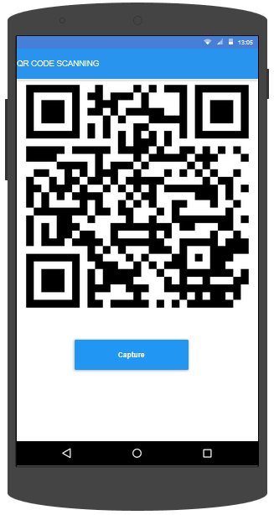

Capture button is clicked to invoke the QR code scanner and the user scans the QR code placed in front of his/her sit.

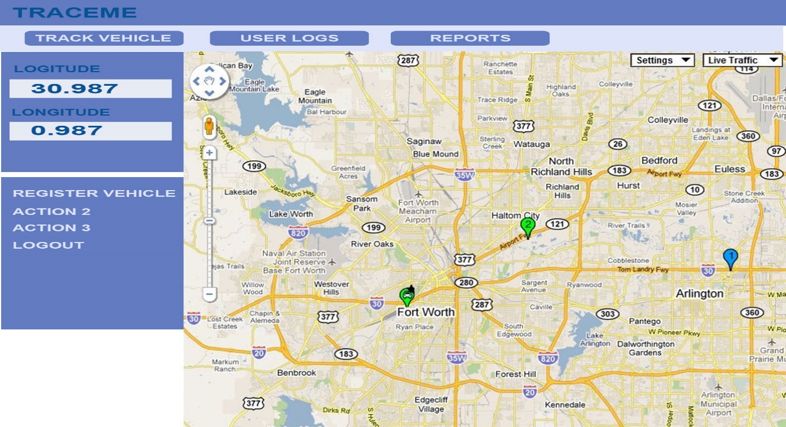

Home Screen of the online web portal which provides a number of functionality such as tracking vehicles by clicking the Track Vehicle tab and entering the vehicle ID number which will pick the latest registered location and pin point it on the map.

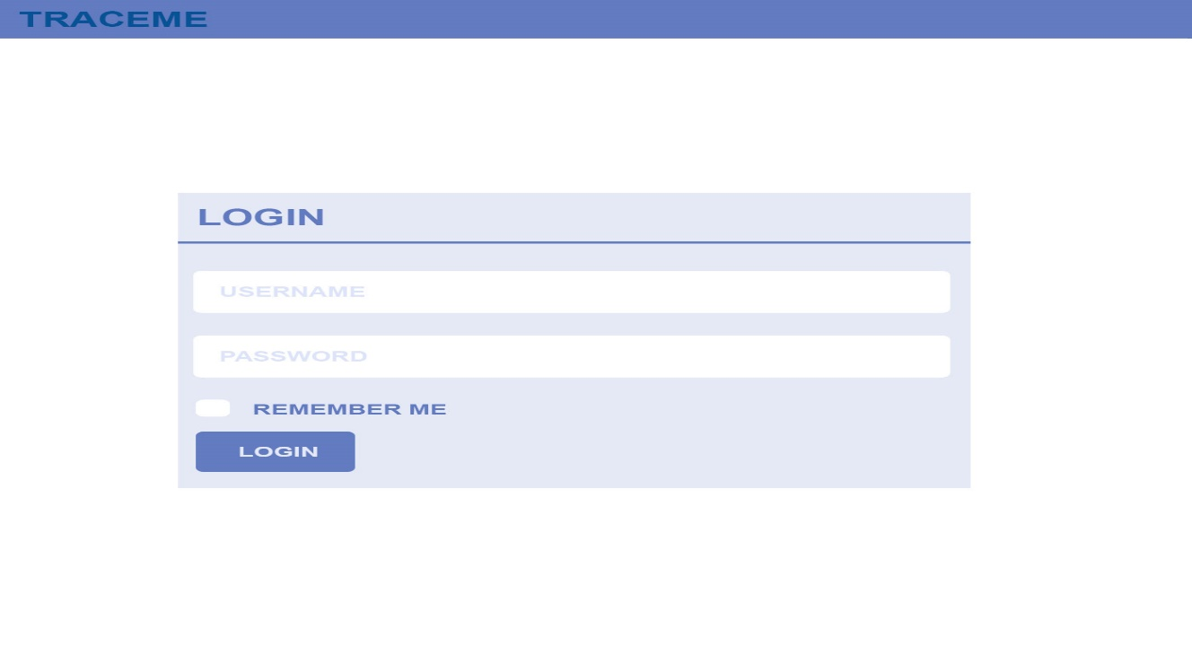  
User name and password fields are input and the login button is clicked to process the provided data and check for validity from the information in the database. If valid then the user is taken to the home screen.

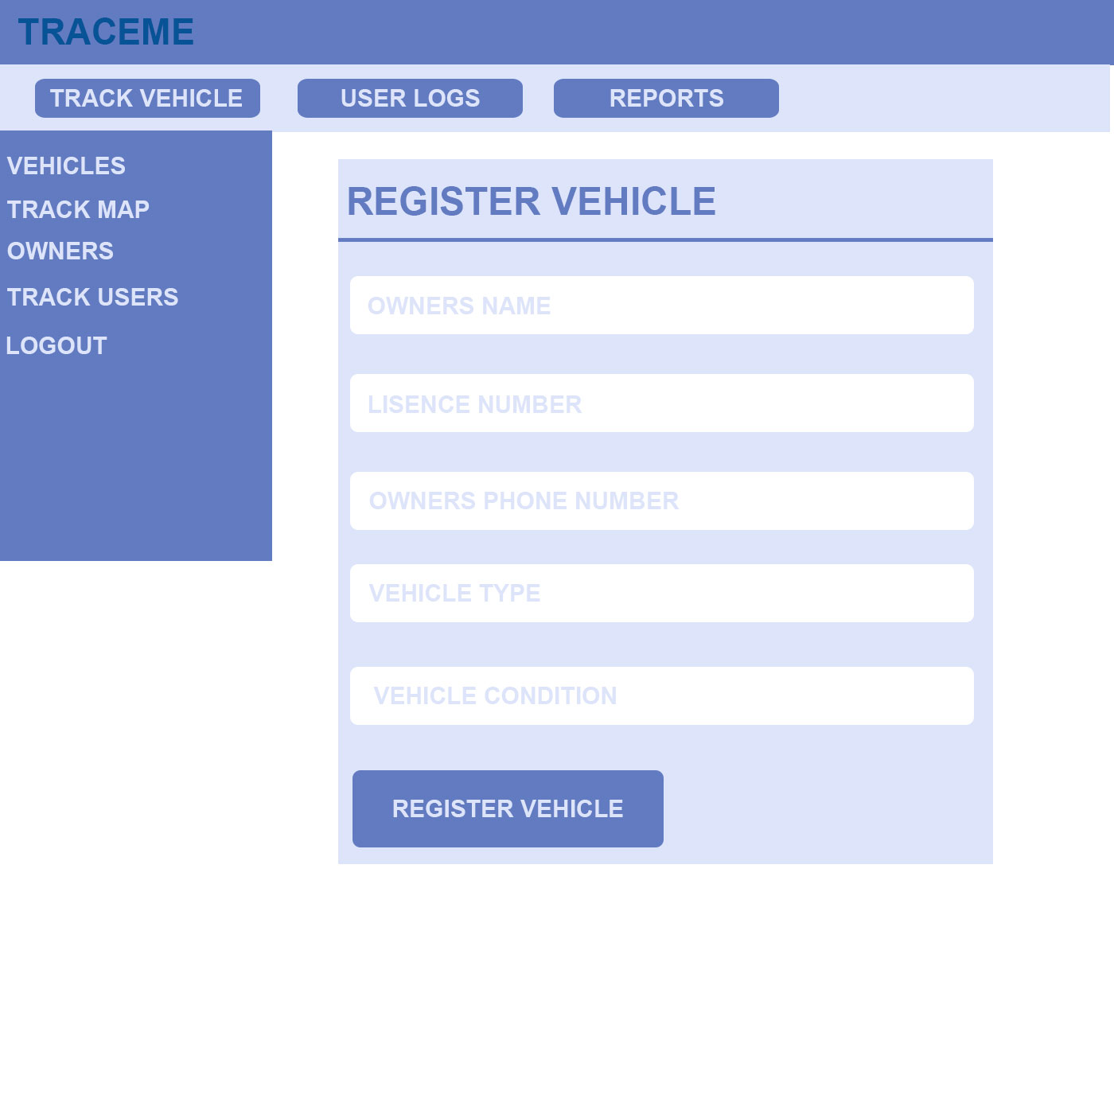

Vehicle registration is done by the administrators by filling the provided information of the vehicles which include plate number, license number, Owners name, owner’s phone number.

## 3.2 Functions

This section includes the requirements that specify all the fundamental actions of the software system. They include the following;

* The system shall accept and store the registration details of each passenger who downloads and installs the application.
* The system shall check for validity of the log in details of the passenger, police and administrators.
* The system shall match the vehicle ID the user scans against what has been registered during the vehicle registration.
* The system shall keep recording the locations of the registered vehicles by use of GPS as they are on the move.
* The system shall generate reports about the requested location details and the passenger details regarding a certain vehicle.

## 3.3 Performance Requirements

The application that is supposed to sync information of user and vehicle ID with the current position is to be a mobile Based application whose performance will solely depend on the capabilities of the Android smart Phone held by the User.

The processing of vehicle locations in terms of longitude and latitude on the web-portal by the Google maps API will solely depend on the speed of the internet access on the particular device being used.

## 3.4 Logical Database Requirements

This section specifies the logical requirements for any information that is to be placed into a database.

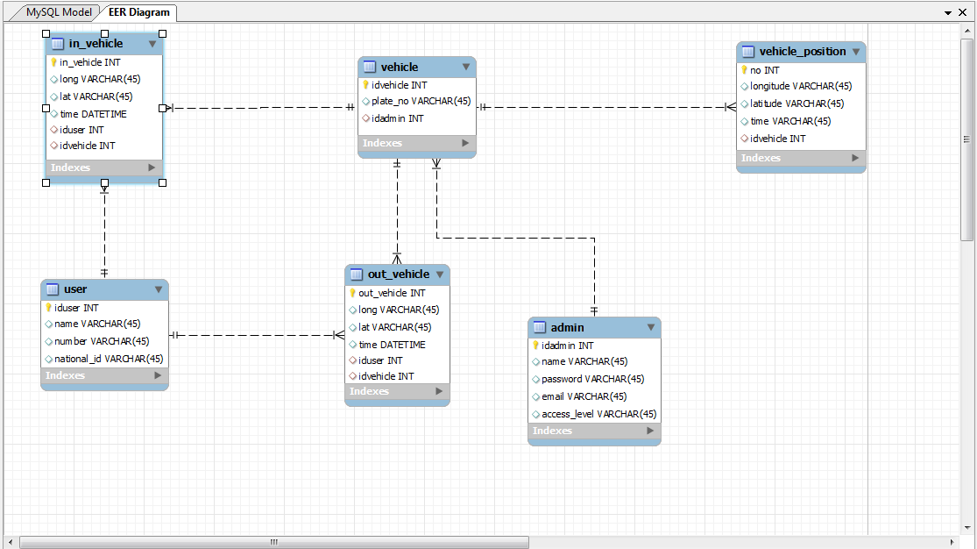

## 3.5 Design Constraints

Budget Constraints; The planned funds might not be enough to fully finance the project over the course of the project development since there is need to acquire hard ware devices like GPS,

### 3.5.1 Standards Compliance

This sub-section includes specification of the requirements derived from existing standards or regulations.

* **Report format**

The format for writing a report is formal and structured in both content and presentation. And all report versions should be named and well stated.

* **Data naming**

This section helps us illustrate the form and standard we shall use in naming our logical entities and physical tables and columns.

The purpose of the logical data model is to show the data that the application must store in order to satisfy business requirements. It also shows how this data is related. Logical data models are generated by identifying each entity, or object, along with its attributes, or characteristics, that the business records information about.

The name used to define each entity must be unique within the enterprise.

The purpose of the physical data model is to show how the data elements will be implemented and stored on the database

## 3.6 Software System Attributes

This section covers the non-functional requirements of traceme system. Also known as the system attributes.

### 3.6.1 Reliability

Specify the factors required to establish the required reliability of the software system at time of delivery. If you have MTBF requirements, express them here. This doesn’t refer to just having a program that does not crash. This has a specific engineering meaning.

Under this part, factors required to establish the required reliability are specified.

Software reliability is defined as the probability of failure-free operation of a software system for a specified time in a specified environment.

Factors required include the speed of internet the passenger shall be using, the correctness of the IDs passengers shall be using to log in and the reset password option so that users are able to use the system always even when they forget their passwords.

### 3.6.2 Availability

The system shall be available and in use as long as the public vehicles are working.

### 3.6.3 Security

In order for a passenger to use the system, he will be required to enter a unique identification number for the vehicle by scanning the QR code.

The information gathered by the system shall only be accessed by the administrators of the system who are authenticated.

Passengers basic information shall be obtained when he first installs and registers with the application to his mobile device.

The log-in details are shall be encrypted so they are not visible.

### 

### 3.6.4 Maintainability

The code should be well documented so that other programmers can easily make changes and enable the future evolution of the application.

The documentation made during the development shall always be referred to during maintenance in order to ease the process.

The use of easy and understandable programming languages shall be used to develop the system such that maintenance shall be easy.

### 3.6.5 Portability

The system shall be developed using programming languages that platform free i.e that their code will be host-independent.

The application shall be portable with iOS and android.

# 4. Change Management Process

Significant changes to the TRACEME System can affect the development, the integrity of the system, as well as, the demand on the resources available. Therefore in case of any new requirement that is supposed to be integrated in the system the entire development team have to seat and come to an agreement, they have to analyze the impact of the change

The SRS shall be produced in three versions where the first version is the draft that will be discussed with the supervisor of the projects for updates and corrections. The second version shall be sent to the key stakeholders in order to clarify and or even update their need for the system. And, the third version will be the final SRS document for which the design team shall consider to develop the system design.

# 5 Document Approvals

Our proposed system’s SRS shall be approved by the project supervisor as well as the project coordinator.

**Supervisor name:** **Overall Project Coordinator:**

Dr Kanagwa Benjamin Mr Kamulegeya Grace

# 6 Supporting Information